
Department of Computer Science and Engineering CS23334 Fundamentals of Data Science Lab
III semester II Year (2023R)

Name of the Student : SHERIN KATHERINA D
Register Number : 240701495

EXPERIMENT NO: 1A
Analyze the trend of data science job postings over the last decade

Aim:
To visualize the trend of Data Science job postings from 2014 to 2023 using a line graph in Python with the help of Pandas, Matplotlib, and Seaborn libraries.
Program:
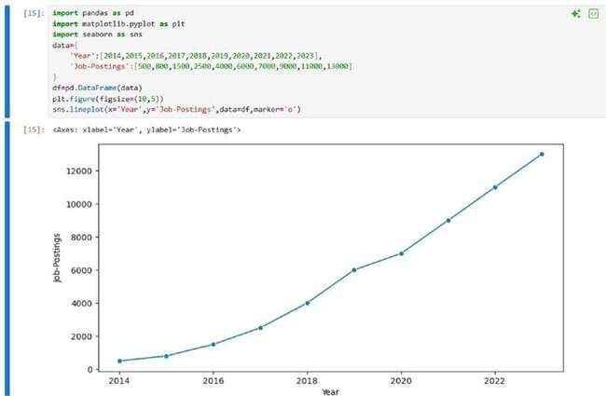

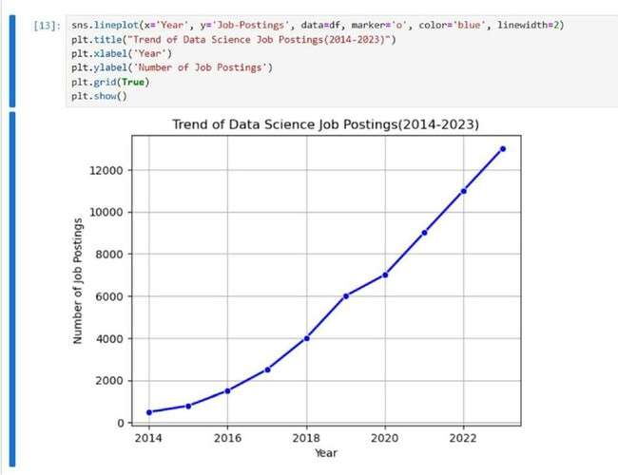
Result:
The program successfully displays a line graph showing a steady increase in Data Science job postings from 2014 (500) to 2023 (13,000).

EXPERIMENT NO: 1B
Analyze and visualize the distribution of various data science roles
Aim:
To visualize the distribution of different Data Science roles and their counts using bar and pie charts with Python libraries — Pandas, Matplotlib, and Seaborn.

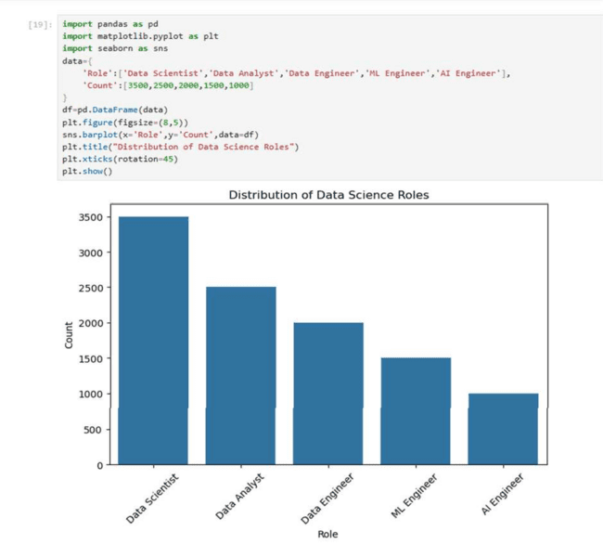
Program

Result:
The program successfully displays a bar chart and a pie chart showing that Data Scientist has the highest count and AI Engineer has the lowest count among the data science roles.

EXPERIMENT NO: 1C
Conduct an experiment to differentiate Structured , Un-structured and Semi structured data
Aim:
To demonstrate the three types of data — structured, semi-structured, and unstructured — and display them in Python.
Program:
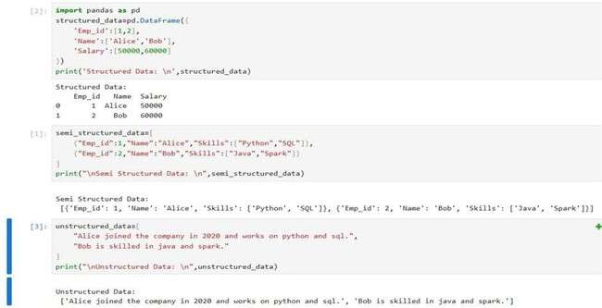

Result:
Data can be structured, semi-structured, or unstructured. Structured data is organized in tables, semi-structured data has some organization like JSON, and unstructured data is plain text without a fixed format.

EXPERIMENT NO: 1D
Conduct an experiment to encrypt and decrypt given sensitive data.
Aim:
To securely encrypt and decrypt a sensitive message (like a password) using symmetric encryption with Fernet from the cryptography library.
Program:
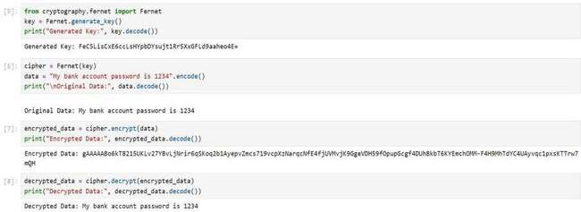
Result:
The program aims to securely encrypt and decrypt a message using Fernet symmetric encryption. It generates a key, converts the message into bytes, encrypts it into unreadable data, and then decrypts it back to the original message. The result shows that the original message is safely restored after encryption.

EXPERIMENT NO: 2
Upload and Analyze the data set given in csv format and perform data preprocessing and visualization
Aim:
To analyze and visualize sales data, clean missing values, summarize total sales and quantities per product, and examine correlations between numeric variables.

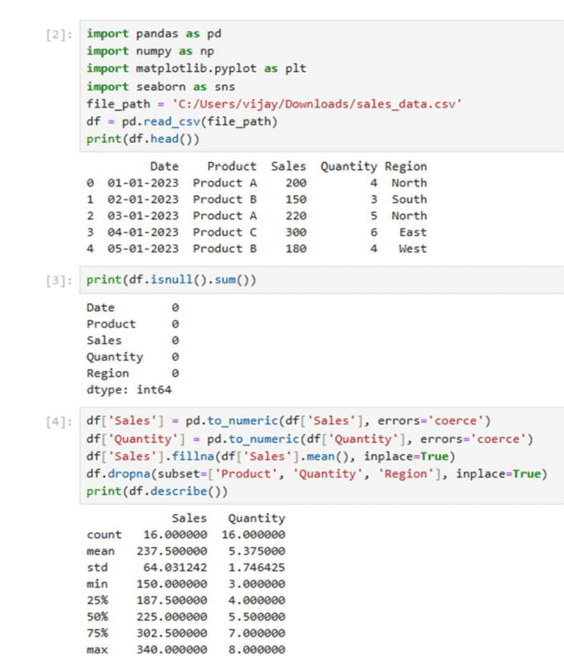
Program:

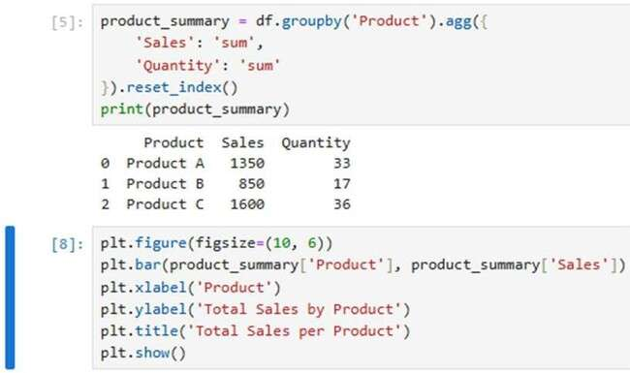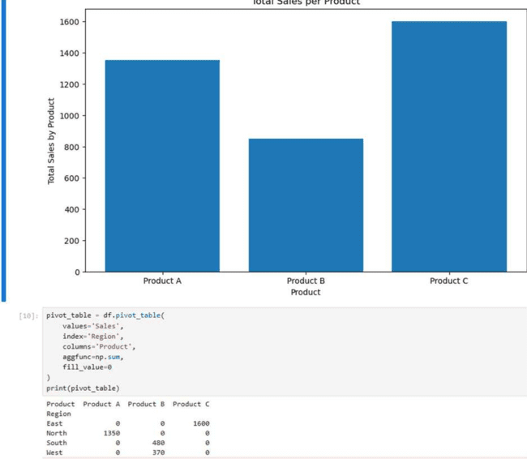

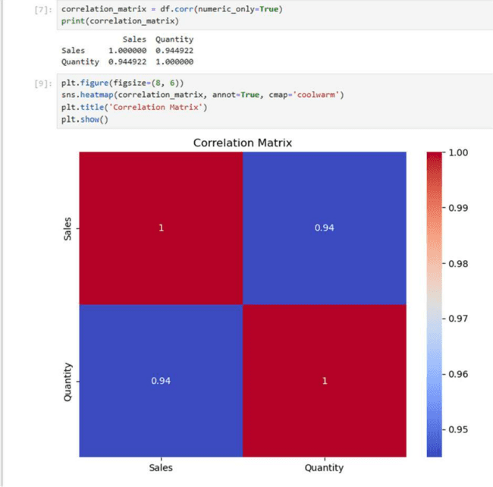
Result:
The dataset was cleaned, total sales and quantities per product were calculated, the bar chart highlighted top-selling products, the pivot table showed regional sales distribution, and the correlation matrix revealed a strong positive relationship between quantity and sales.

EXPERIMENT NO: 3A
Data Preprocessing and Encoding for Machine Learning
Aim:
To preprocess a dataset by handling missing values, encoding categorical variables, and preparing it for analysis or machine learning.
Program:
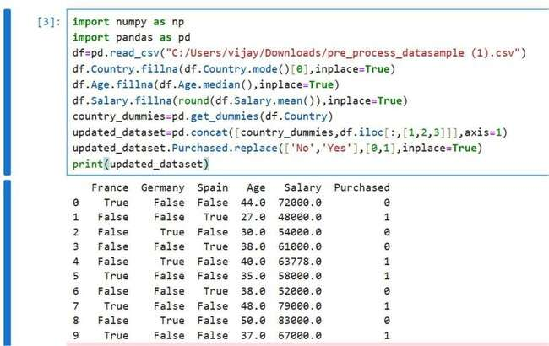

Result:
A cleaned and transformed dataset where all missing values are replaced, categorical variables are converted into numeric form, and the Purchased column is ready for modeling. Each row now has numeric values only, suitable for machine learning or statistical analysis.

EXPERIMENT NO: 3B
Hotel Dataset Cleaning and Preprocessing
Aim:
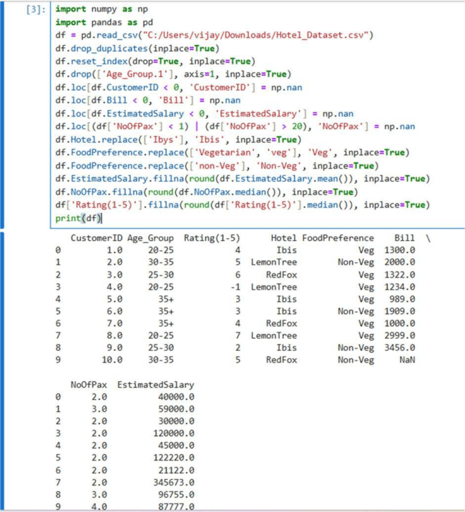
To clean and preprocess the hotel dataset by removing duplicates, correcting invalid and inconsistent values, filling missing data, and standardizing text entries, making it ready for analysis or machine learning.

Program:

Result:
A cleaned and consistent hotel dataset with no duplicates, corrected text values, invalid numerical entries replaced, and missing values filled, ready for analysis or modeling.

EXPERIMENT NO: 3C
Airline Flight Dataset Generation and CSV Export
Aim:
To generate a synthetic dataset of airline flights with random flight details (IDs, airlines, source and destination cities, departure/arrival times, durations, and fares) and export it as a CSV file for analysis or testing purposes.
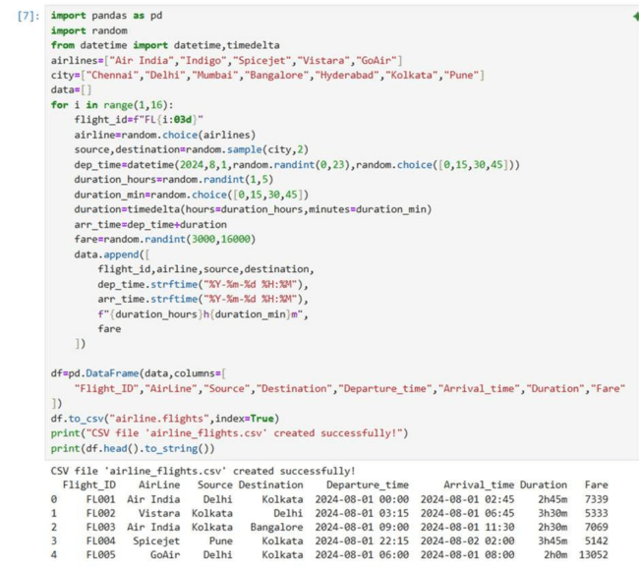
Program:

Result:
A CSV file "airline.flights" containing 15 randomly generated flight records with columns: Flight_ID, AirLine, Source, Destination, Departure_time, Arrival_time, Duration, and Fare. The dataset can be used for analysis, testing, or simulations.

EXPERIMENT NO: 4
Outlier Detection and Visualization using IQR
Aim:
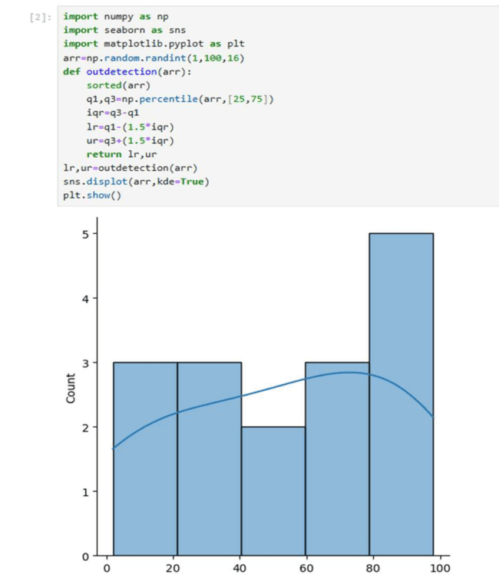
To detect and remove outliers from a dataset using the Interquartile Range (IQR) method and visualize the data distribution before and after outlier removal.

Program:

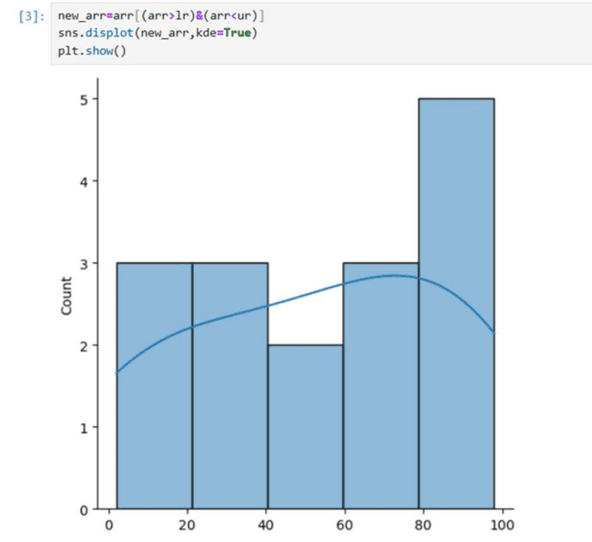

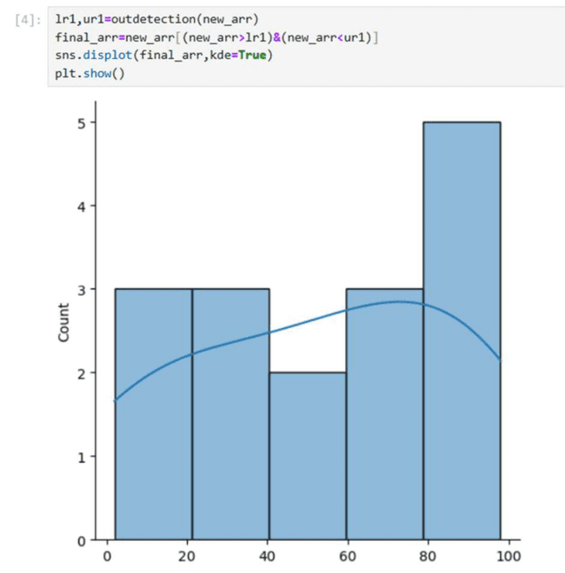

Result:
The code removes extreme values from a random dataset using IQR, showing three plots: original data, after first outlier removal, and after final outlier removal, resulting in a cleaner, more representative dataset.

EXPERIMENT NO: 5
Experiment to understand feature scaling.
Aim:
To preprocess a dataset by handling missing values, encoding categorical variables, and scaling features using StandardScaler and MinMaxScaler.
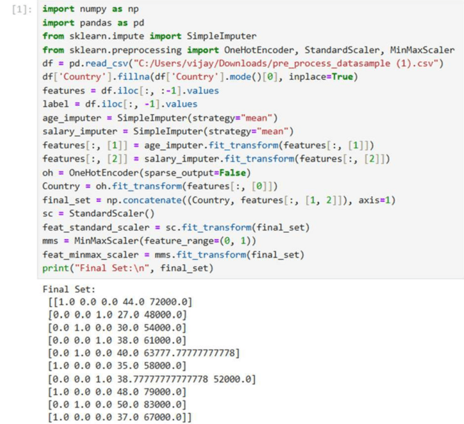
Program:

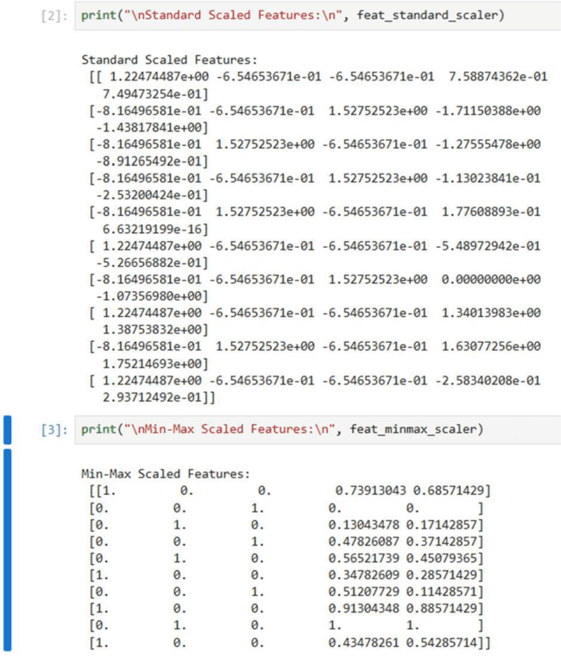
Result:
The dataset is cleaned and numeric features are combined with one-hot encoded Country. Standard scaling centers the data, while Min-Max scaling normalizes it between 0 and 1, making it ready for machine learning.

EXPERIMENT NO: 5
Data Visualization using Seaborn
Aim:
To explore and visualize the tips dataset using various plots to understand distributions, relationships, correlations, and categorical counts.

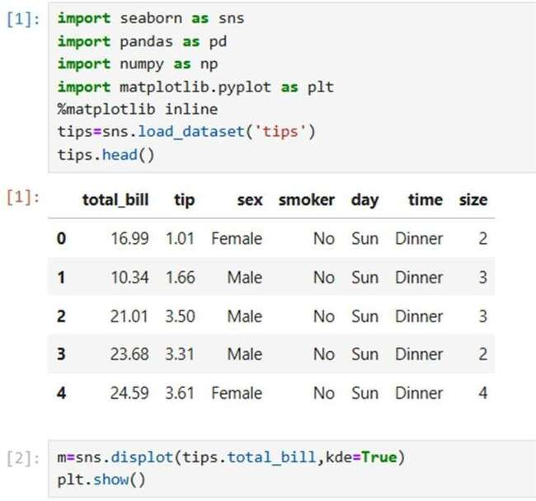
Program:

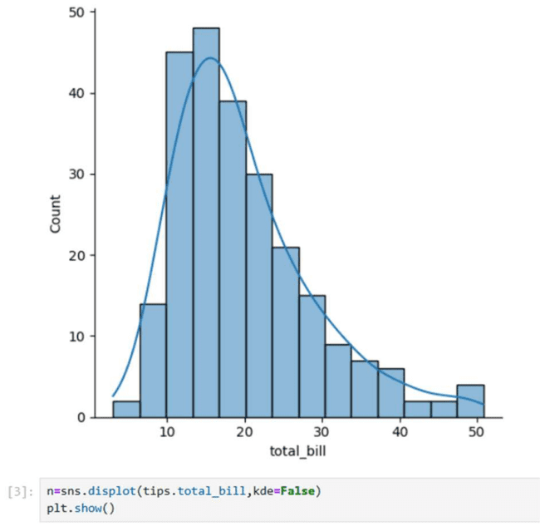

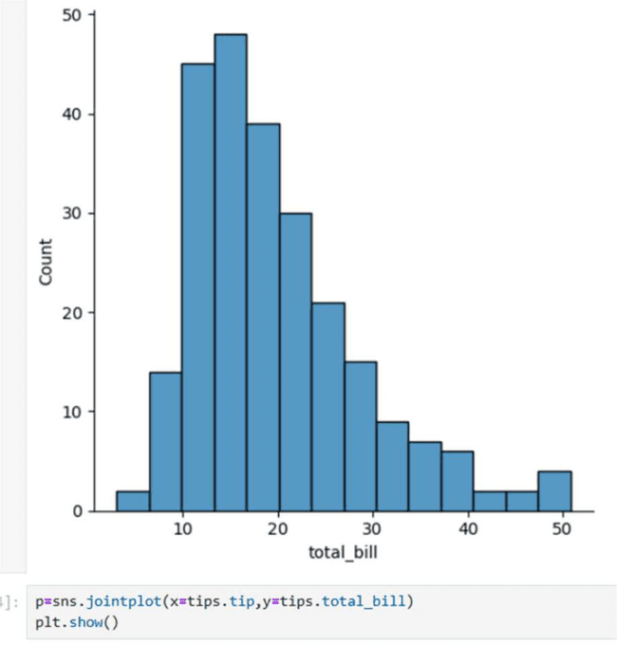

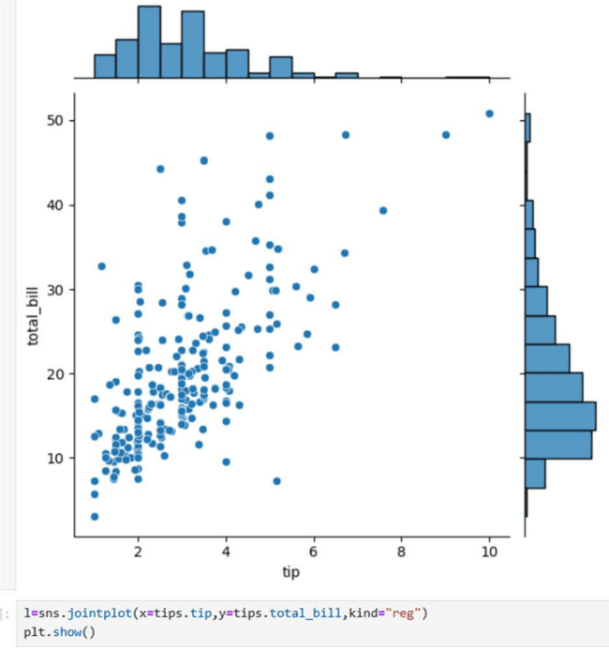

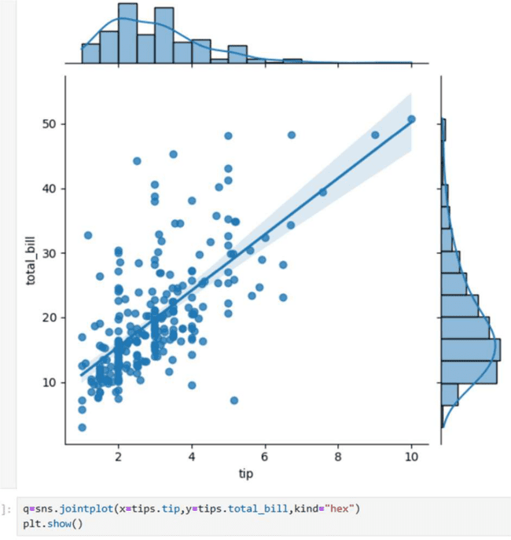

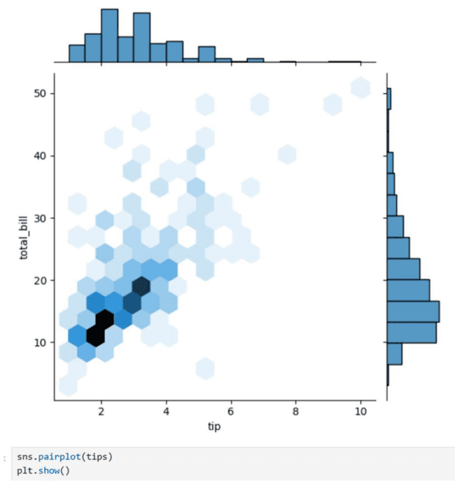

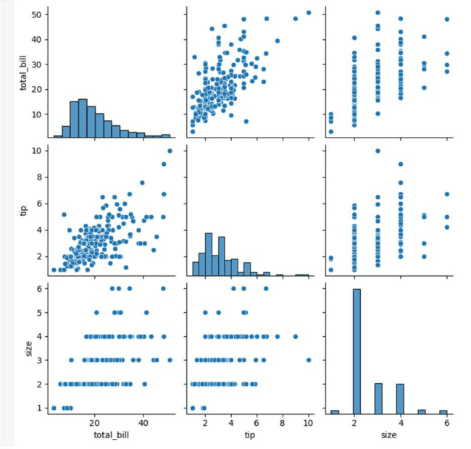
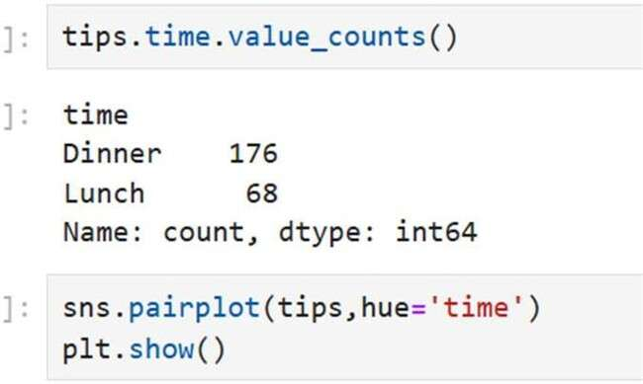

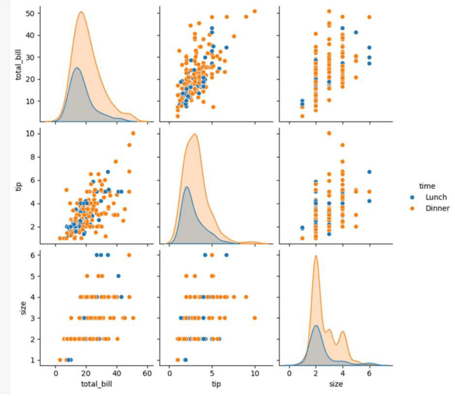

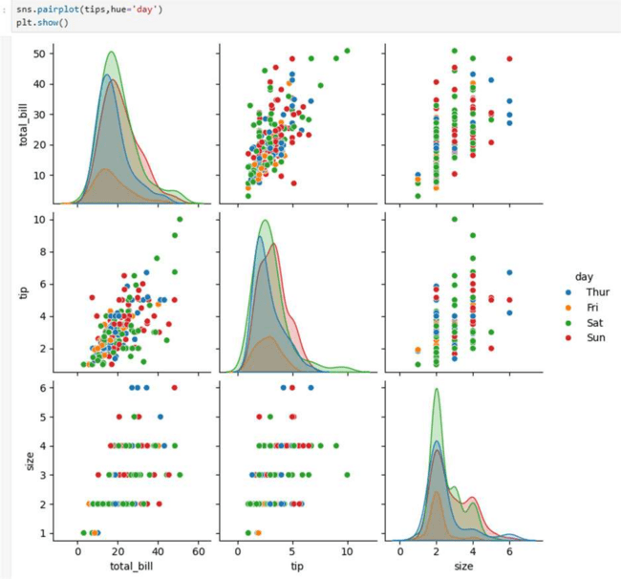

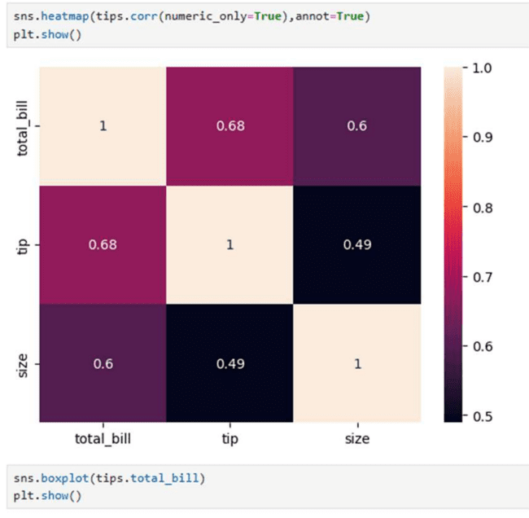

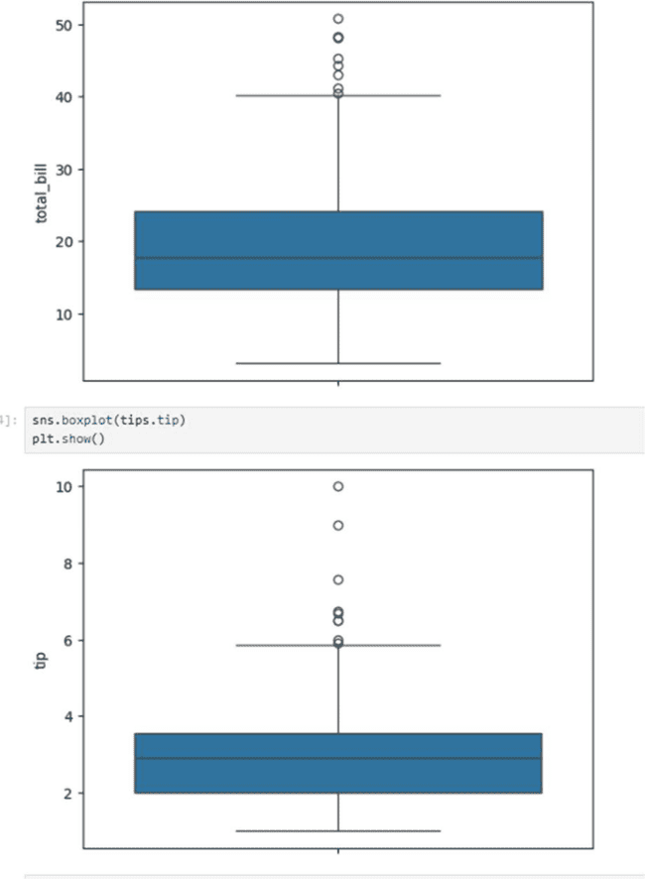

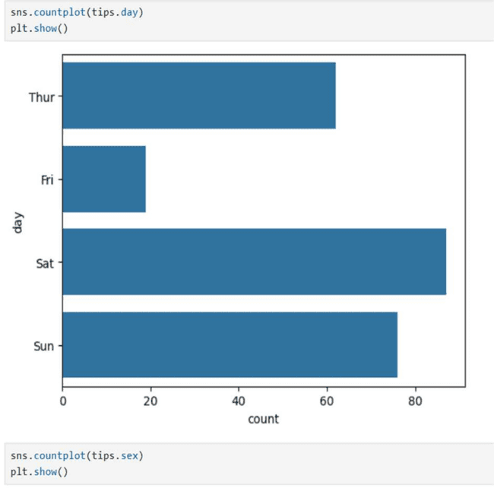

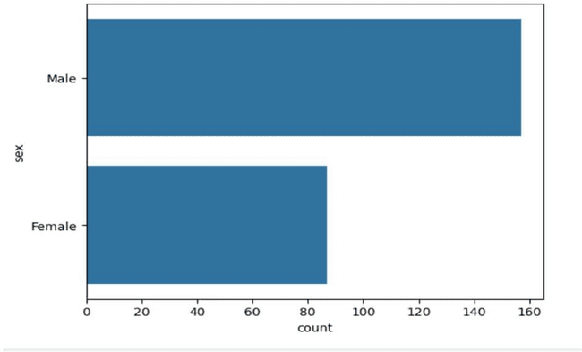
Result:
The visualizations show distributions of bills and tips, relationships between tip and total bill, correlations among numeric features, outliers, and counts by day and gender, providing a clear overview of the dataset.

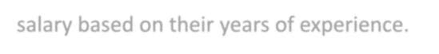
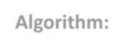
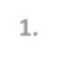
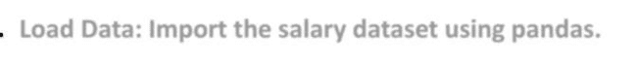
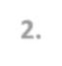
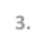
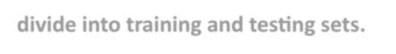


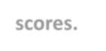
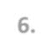

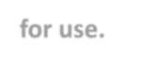


EXPERIMENT NO: 7
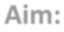
Salary Prediction using Linear Regression
Aim:

To build and train a linear regression model that predicts an employee’s salary based on their years of experience.
Algorithm:
- Load Data: Import the salary dataset using pandas.
.
- Clean Data: Check for missing values and remove null entries.
.
- Split Data: Separate features (YearsExperience) and labels (Salary), then divide into training and testing sets.
.
- Train Model: Fit a LinearRegression model using the training data.
.
- Evaluate Model: Calculate model accuracy using training and testing scores.
.
- Model Parameters: Display slope (coef_) and intercept (intercept_).
.
- Save & Load Model: Save the trained model using pickle and reload it for use.
.
- Prediction: Take user input for years of experience and predict the corresponding salary.
.

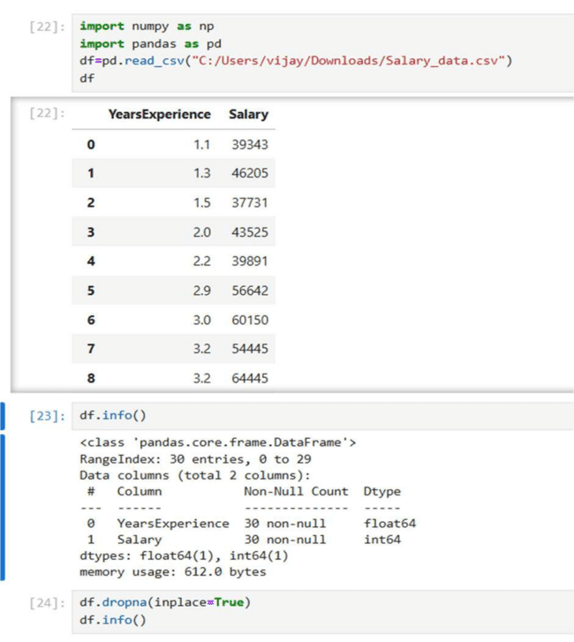
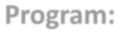
Program:

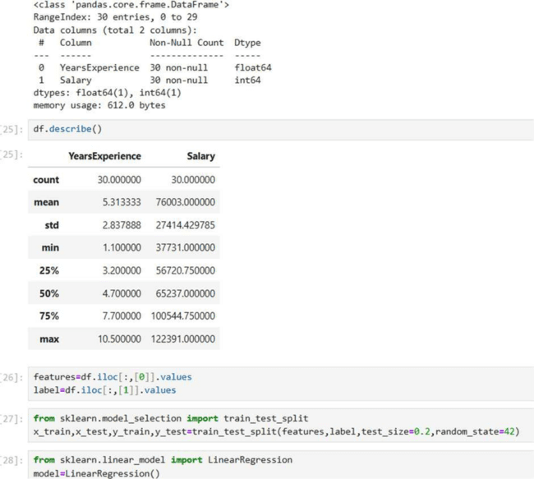

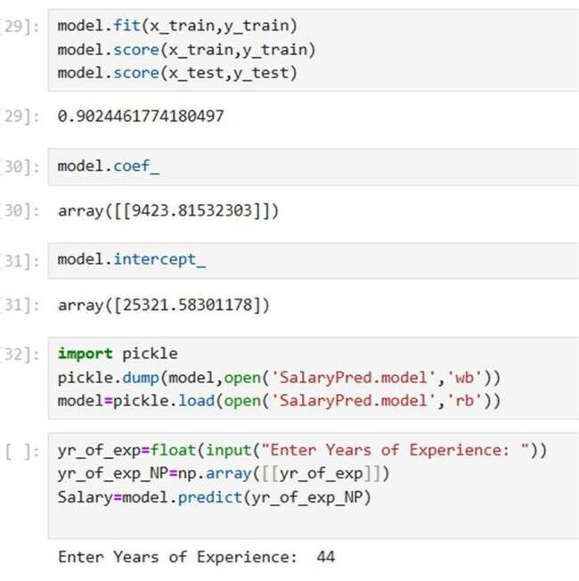
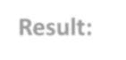

Result:
The trained linear regression model accurately predicts salary based on years of experience. The model is saved for future use, and upon entering a number of years, it outputs the estimated salary value.

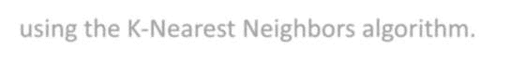


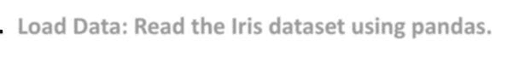

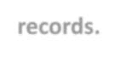



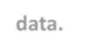



EXPERIMENT NO: 8

Iris Flower Classification using K-Nearest Neighbors (KNN)
Aim:

To classify Iris flower species based on their sepal and petal measurements using the K-Nearest Neighbors algorithm.
Algorithm:
- Load Data: Read the Iris dataset using pandas.
.
- Explore Data: Check data info, count species, and display sample records.
.
- Split Data: Separate features (measurements) and labels (species).
.
- Train-Test Split: Divide data into 80% training and 20% testing sets.
.
- Model Training: Initialize KNN with 5 neighbors and fit it on training data.
.
- Evaluate Model: Display training and testing accuracy scores.
.
- Performance Metrics: Generate and print confusion matrix and classification report.
.


Program:
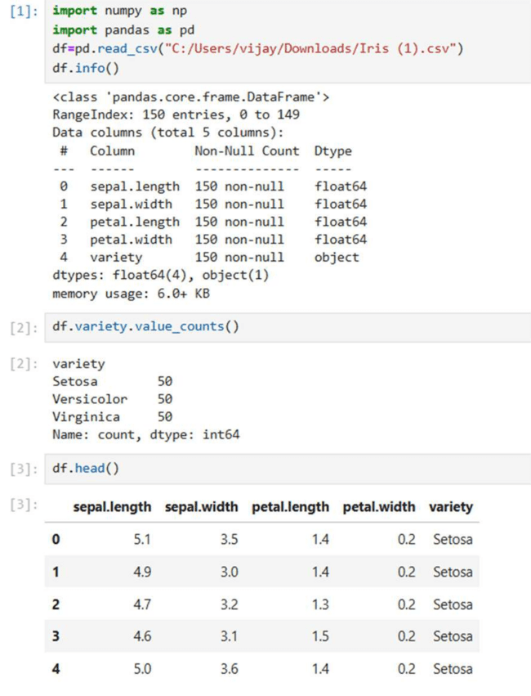

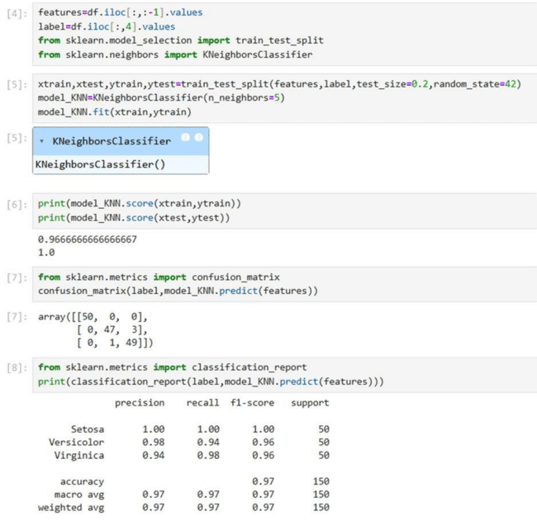

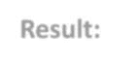

Result:
The KNN model successfully classifies Iris flowers into their respective species with high accuracy. The confusion matrix and classification report confirm that the model performs well with minimal misclassifications.




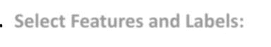
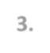
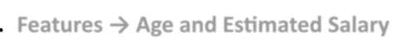

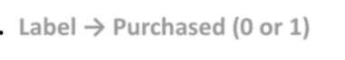

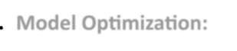


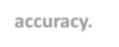

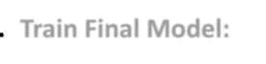
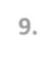
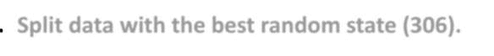
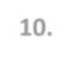
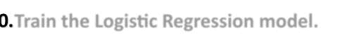
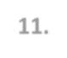
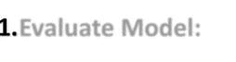
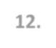
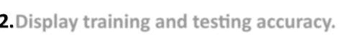
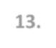
EXPERIMENT NO: 9

Social Network Ads Classification using Logistic Regression
Aim:

To build a Logistic Regression model that predicts whether a user purchases a product based on their age and estimated salary.
Algorithm:
- Load Data: Read the Social Network Ads dataset using pandas.
.
- Select Features and Labels:
.
- Features → Age and Estimated Salary
.
- Label → Purchased (0 or 1)
.
- Model Optimization:
.
- Run multiple train-test splits with different random states (1–400).
.
- Identify the state where the test accuracy exceeds the training accuracy.
.
- Train Final Model:
.
- Split data with the best random state (306).
.
- Train the Logistic Regression model.
0.
- Evaluate Model:
1.
- Display training and testing accuracy.
2.
- Generate classification report to assess precision, recall, and F1-score.
3.

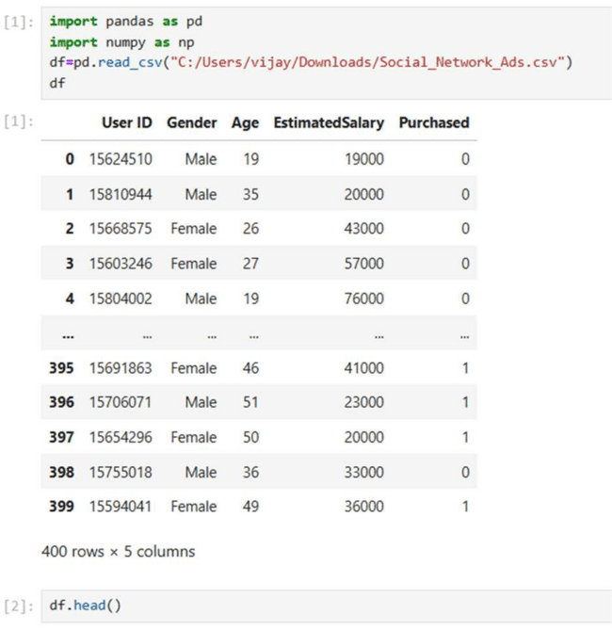

Program:

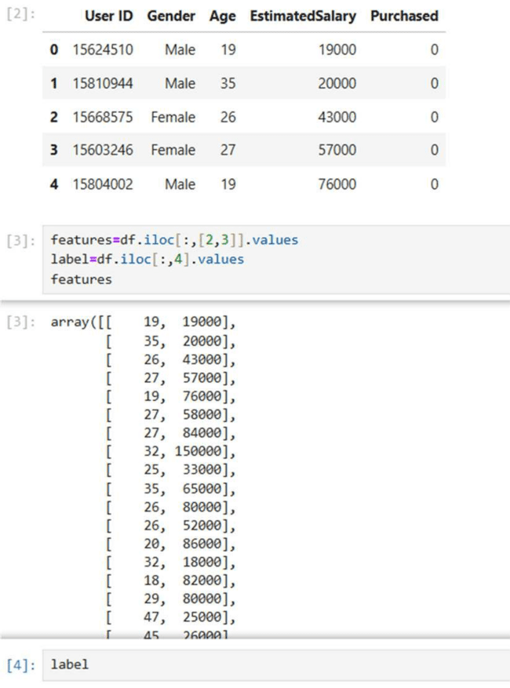

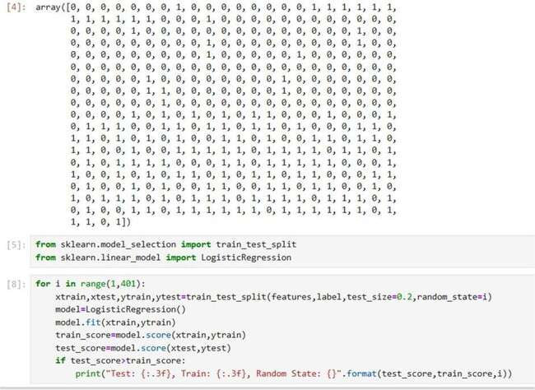

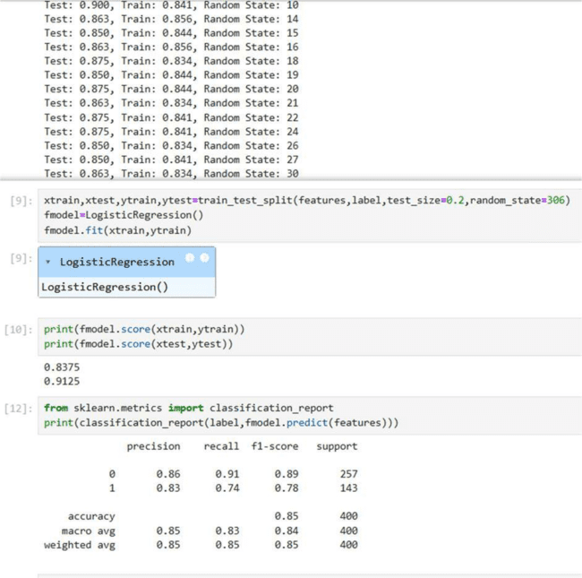

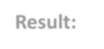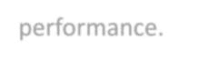

Result:
The Logistic Regression model effectively predicts whether a customer will purchase based on age and salary. The model shows balanced training and testing accuracy, and the classification report confirms good overall performance.





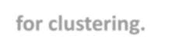

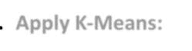

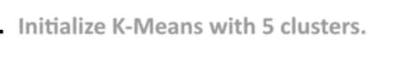
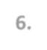

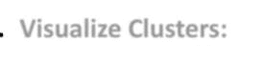

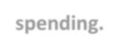

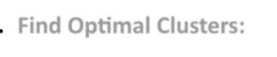

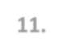
EXPERIMENT NO: 10

Customer Segmentation using K-Means Clustering
Aim:

To segment mall customers into distinct groups based on their annual income and spending score using the K-Means clustering algorithm.
Algorithm:
- Load Data: Import the Mall_Customers.csv dataset using pandas.
.
- Visualize Data: Use pairplot() to observe relationships among features.
.
- Select Features: Extract Annual Income (k$) and Spending Score (1-100) for clustering.
.
- Apply K-Means:
.
- Initialize K-Means with 5 clusters.
.
- Fit the model and assign cluster labels to each customer.
.
- Visualize Clusters:
.
- Plot scatter points showing different clusters based on income and spending.
.
- Find Optimal Clusters:
.
1 Calculate WCSS (Within-Cluster Sum of Squares) for cluster counts 1–9.
0.
1 Plot the Elbow Curve to determine the best number of clusters.
1.

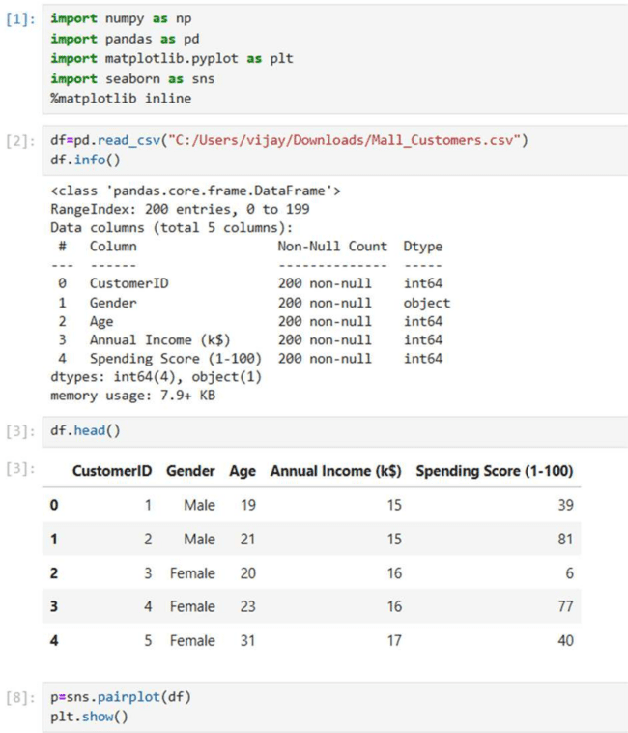

Program:

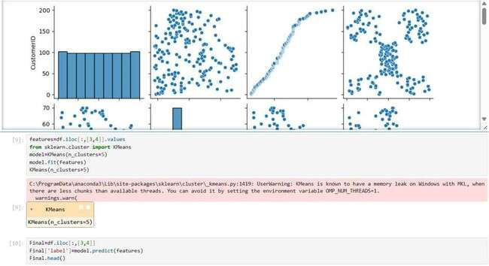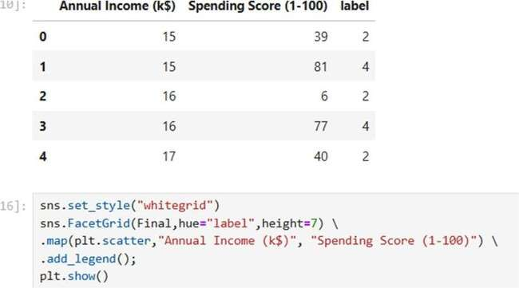

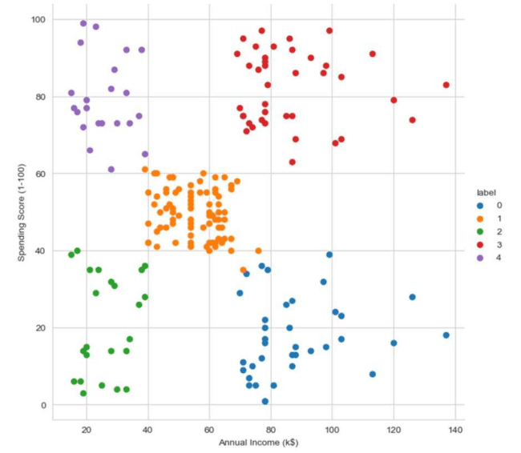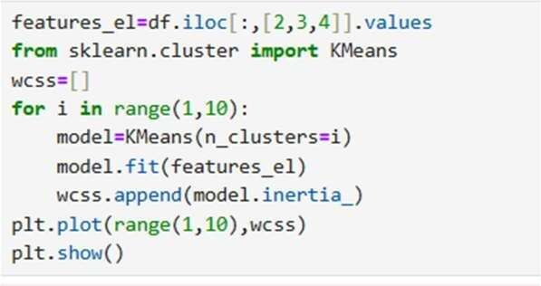

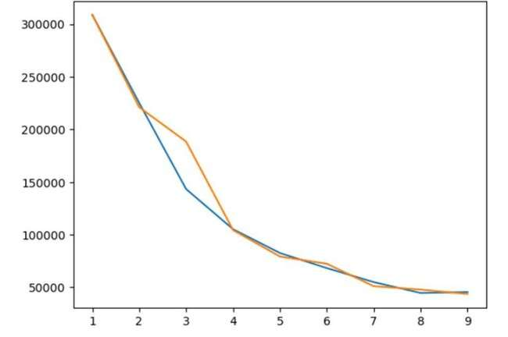

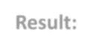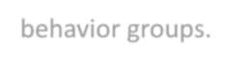

Result:
The K-Means algorithm groups customers into 5 clusters based on their spending habits and income. The Elbow Method helps confirm that 5 clusters provide the most balanced segmentation, clearly showing different customer behavior groups.

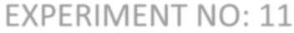
EXPERIMENT NO: 11
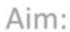
Random Sampling and Sampling Distribution
Aim:

To explore random sampling from a population and understand the concept of sampling distribution using Python in Jupyter Notebook.

Algorithm:

- Initialize population parameters
- Generate the population
- Select sample sizes
- Repeat sampling
- Compute sample means
- Form sampling distributions
- Plot histograms
- Mark population mean
- Analyze results


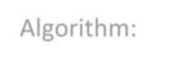

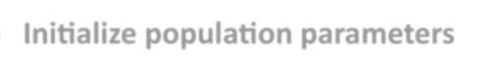



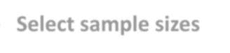

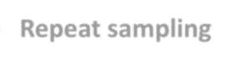

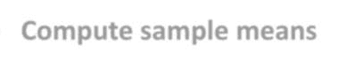

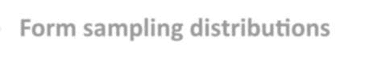

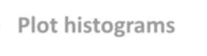



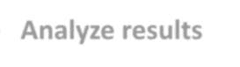

Code:

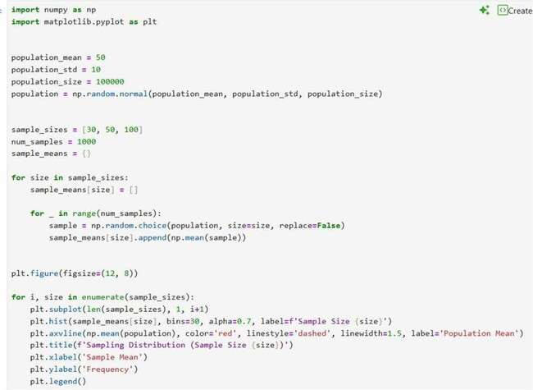
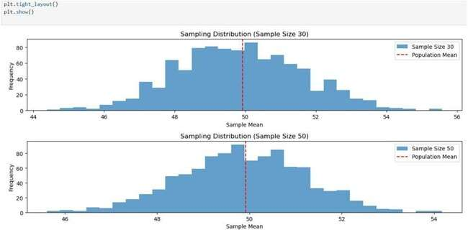
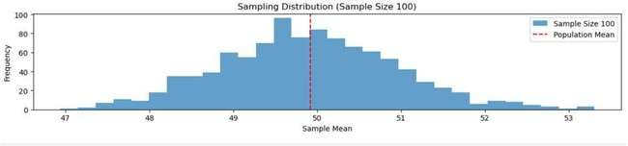

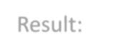
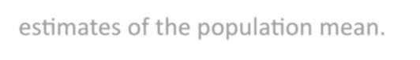
Result:
All sampling distributions are centered around 50, and as the sample size increases, the spread decreases, giving more accurate estimates of the population mean.

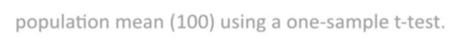
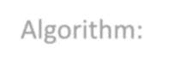

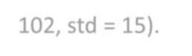


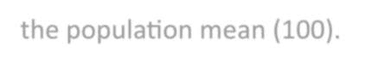


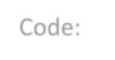
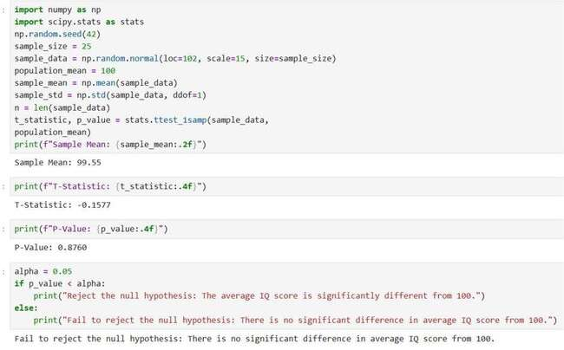
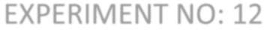
EXPERIMENT NO: 12
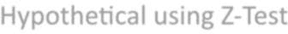

Hypothetical using Z-Test
Aim:

To test whether the sample mean IQ differs significantly from the population mean (100) using a one-sample t-test.
Algorithm:
- Generate a random sample from a normal distribution (mean = 102, std = 15).
- Calculate the sample mean and sample standard deviation.
- Perform a one-sample t-test comparing the sample mean to the population mean (100).
- Compare the p-value with the significance level (α = 0.05).
- If p < α, reject the null hypothesis; otherwise, fail to reject it.
Code:


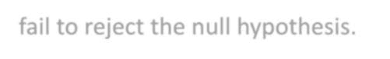
Result:
The test shows that the sample’s average IQ score is not significantly different from the population mean of 100. Hence, we fail to reject the null hypothesis.

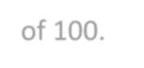
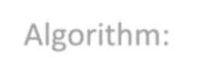

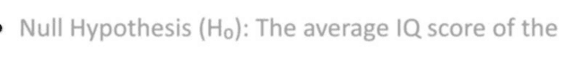
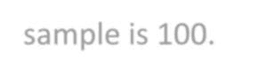

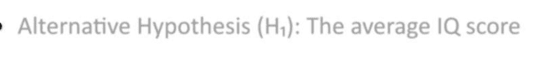
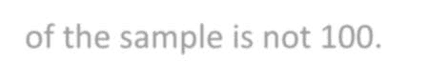

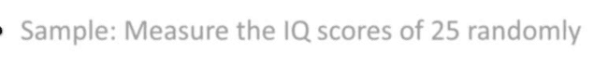
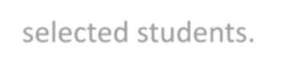

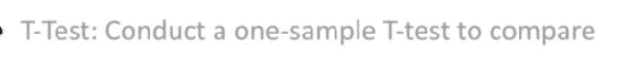
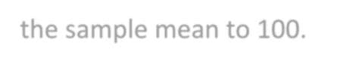

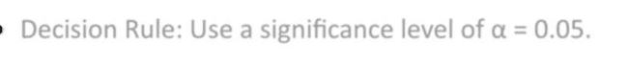

EXPERIMENT NO : 13

Hypothetical using T-Test
Aim:

To test whether the average IQ score of a sample of students differs significantly from a population mean IQ score of 100.
Algorithm:
- Null Hypothesis (H₀): The average IQ score of the sample is 100.
- Alternative Hypothesis (H₁): The average IQ score of the sample is not 100.
- Sample: Measure the IQ scores of 25 randomly selected students.
- T-Test: Conduct a one-sample T-test to compare the sample mean to 100.
- Decision Rule: Use a significance level of α = 0.05.

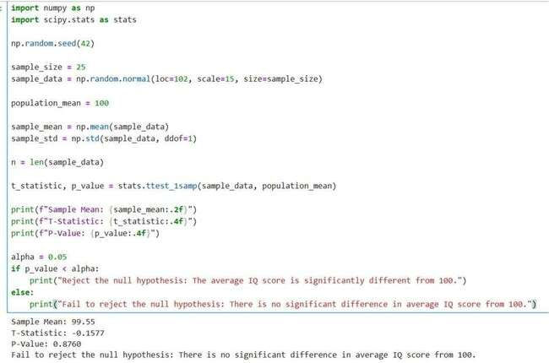

Code:

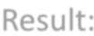
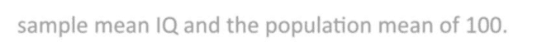
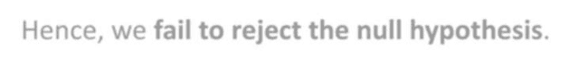
Result:
The test shows no significant difference between the
sample mean IQ and the population mean of 100. Hence, we fail to reject the null hypothesis.

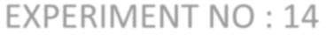
EXPERIMENT NO : 14

Hypothetical using ANOVA-Test
Aim:

To test whether there is a significant difference in the mean growth rates of plants under three different treatments (A, B, and C) using the One-Way ANOVA method.

Algorithm:

- Import required libraries: numpy, scipy.stats, and statsmodels.
- Generate three random samples (growth rates) for treatments A, B, and C.
- Perform One-way ANOVA using stats.f_oneway().
- Compare the obtained p-value with significance level α = 0.05.
- If significant, perform Tukey’s HSD post-hoc test to find which groups differ.

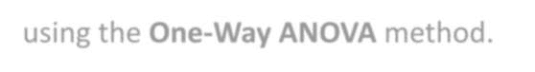


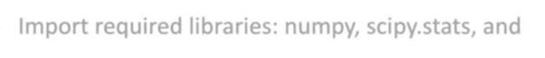
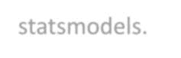


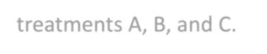

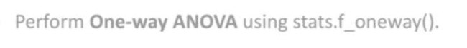

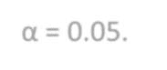

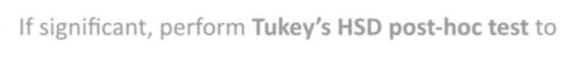
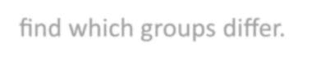

Code:

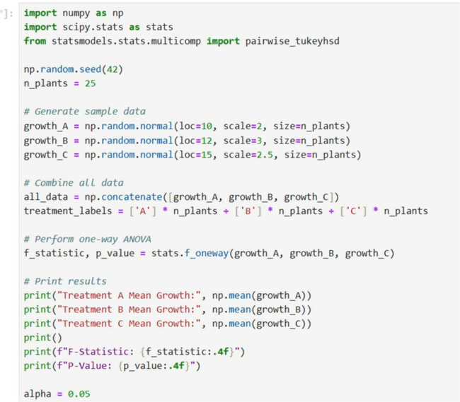
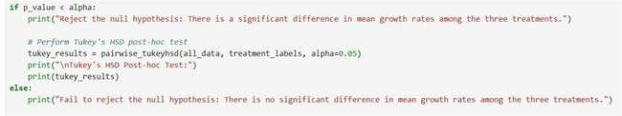


Result:
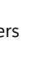
The p-value (< 0.05) indicates that there is a significant difference in the mean growth rates among treatments A, B, and C.
Tukey’s HSD test confirms that each treatment differs significantly from the others

